Assignment 4

Vedant Agrawal

19BCE10057

Develop a mobile application that takes the user input and sends it to IoT device (python code). print the received data in python shell.

Keep a text box to accept the user input.integrate a submit button.

whenever user enters the text input in text box and clicks the button the data should be sent to IBM cloud using URL(HTTP API).

- The Program that we have developed would work and update the Temperature, Humidity and Gas variables continuously while if the user enters some text then it would be visible on the IDLE Shell.
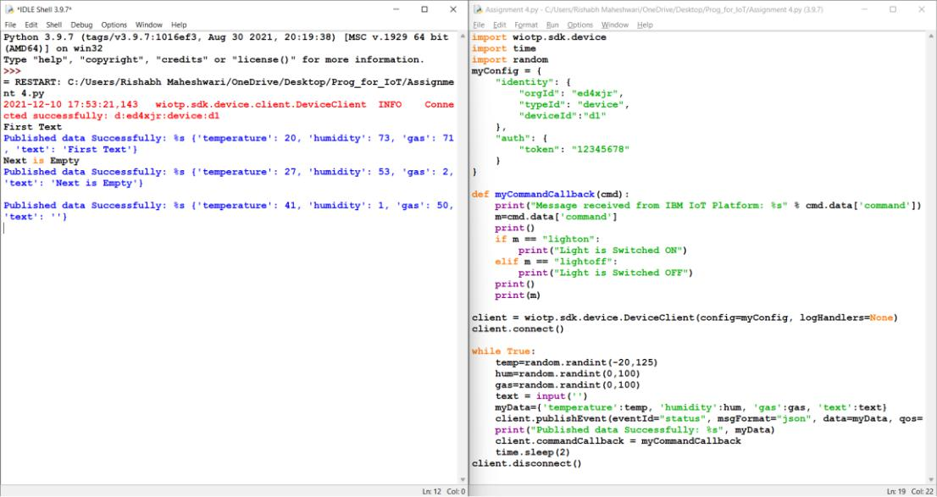

2. Using MIT App Inventor first design the mobile app layout.
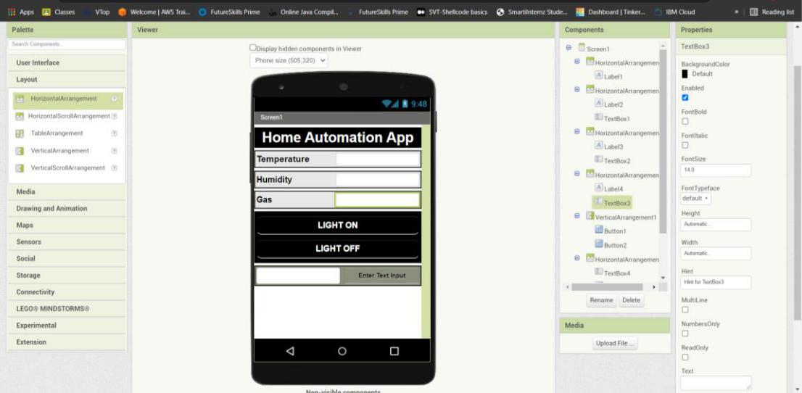

- Design the working of the app using the Blocks available in the MIT App Inventor app.
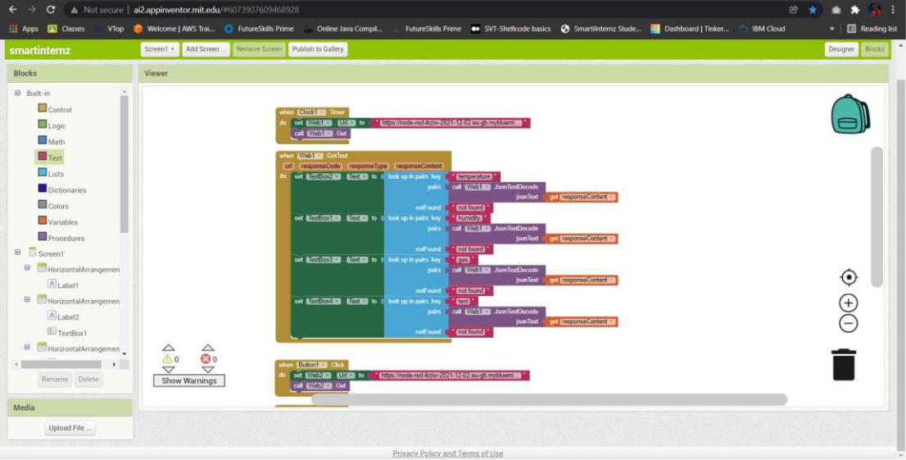
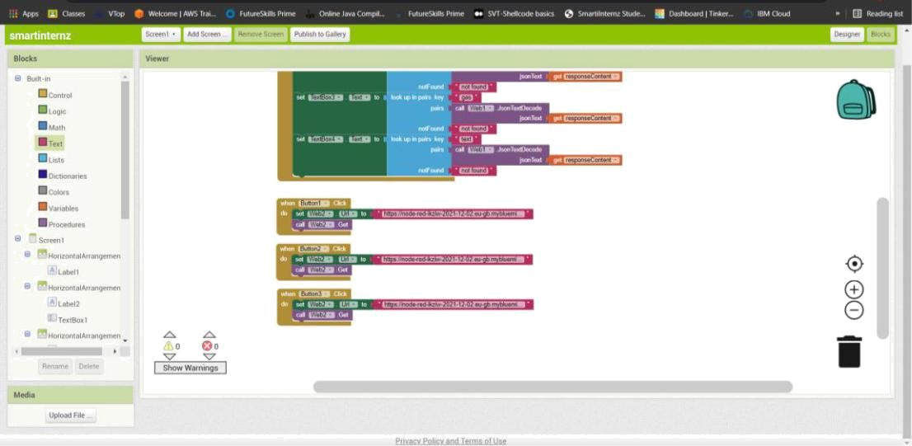

- Configure the Data Flow and Structure of the program on Node-RED application. Output will also be available on Node-RED debug console as shown below.
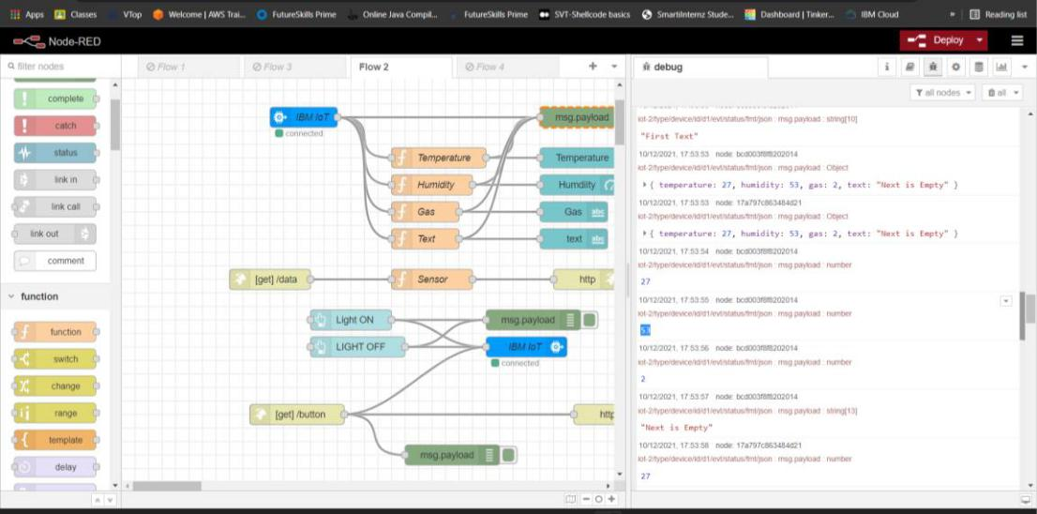
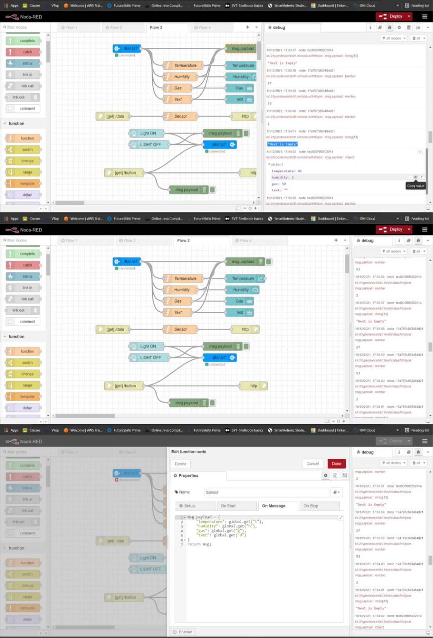

5. Output available on web page using URLs.
